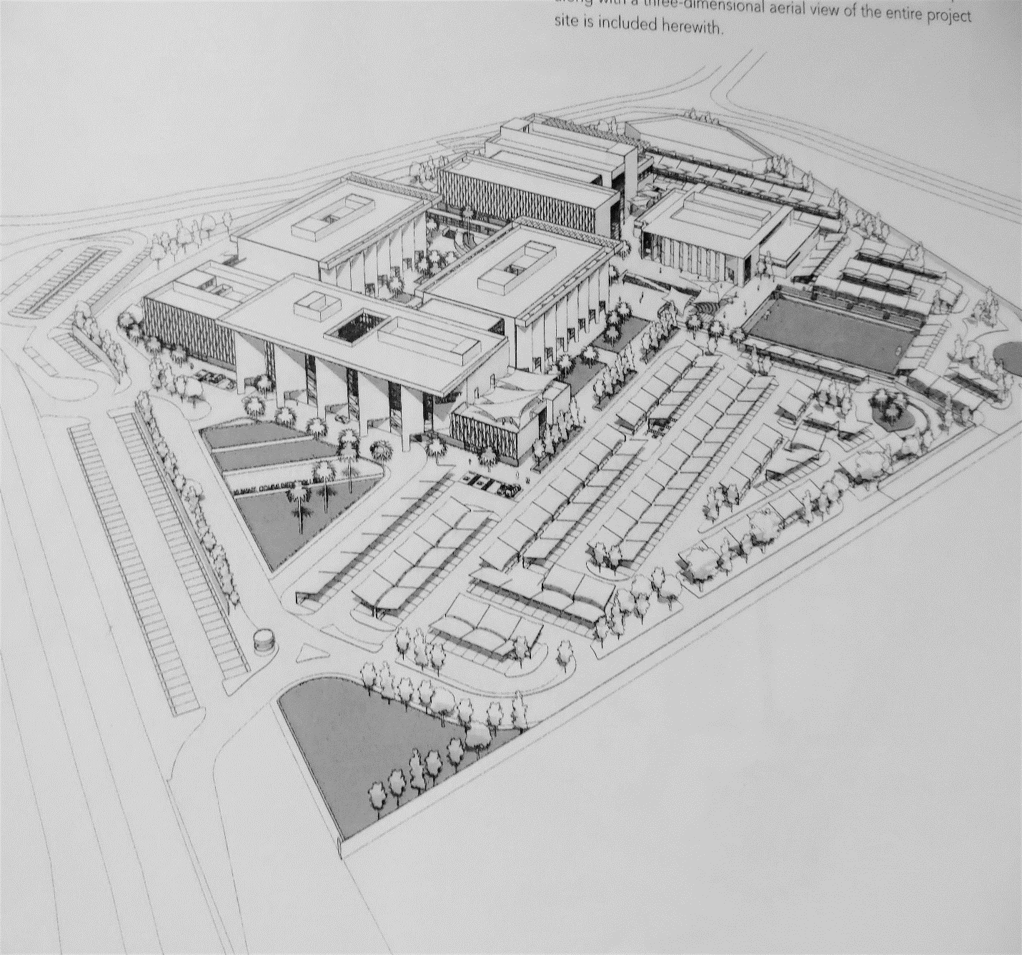

An Introduction to
American International University
Jahra, Kuwait

An Introduction to
American International University
Jahra, Kuwait

A university offering American style education, degrees and majors
- Mission Statement
American International University educates and serves the people of Kuwait. The University provides high-quality, relevant, and varied educational programs and opportunities for the intellectual, cultural, and personal growth of all members of its community. The University values its role as an educational leader that promotes individual development and improves the overall quality of life in a diverse community. It offers academic and professional programs, which lead to degrees from the associate through baccalaureate and masters.

Accredited and approved by the Ministry of Education, Kuwait
- Also, formally affiliated with Broward College, Florida
- Pursuing additional relationship with an outstanding American university offering bachelor and master degrees in Business and Engineering as well as in the arts & sciences

Owned by the Ali Al-Ghanim & Sons Company of Kuwait
Will open for Fall Semester 2019
- Campus will contain three major buildings: Administration and Academic, Student Services & Library, and a gymnasium
- Total gross built up area will be approximately 47,400 sq. meters
- Interior design planning has been done with nbbj, a major US design firm

Planned for a total student body of 2500
- Will open with the Preparatory Program and classes needed for First Year students
- Goal for opening population is 500 students
- Second Year students will start classes in 2020 and upper level classes will begin in 2021
- Students will come from Kuwait
- Current research indicates a student population of about 70% female and 30% male

Admissions Standards
- Will accept all students who have graduated from high school or the equivalent
- Upon admission, students will take placement tests in English and Math to determine if
preparatory non-college credit courses need to be taken before they are approved to take university credit courses
- Preparatory courses will be offered on campus so students will smoothly transition into college credit courses

Academic Information:
- Will operate on the semester system with Fall and Spring semesters being approximately 15 weeks long
- Will follow the local academic calendar, which means that Winter Break will often begin early in January; Western staff should expect to work during Christmas some years
- After a year or more of operation the university plans to offer two 7-week modules during each semester to increase the scheduling flexibility available to our students
- At opening, the following majors/degrees will be offered:
  - School of Business: B.S. in Accounting, Finance and Business Administration
  - School of Engineering: B.S. in Computer Science Engineering, Electrical Engineering, Mechanical Engineering
  - School of Liberal Arts: B.A. in Communications, English
- The number of majors will increase as the student enrollment grows
- A goal is to receive accreditation for our programs from organizations like AACSB and ABET
- In a few years, the University also plans to offer several Master’s programs in a night school plan for currently employed adults, for example an M.B.A.

There will be active, professionally staffed, academic support programs including: academic advising, study skills, remedial academic support and testing

There will be a fully staffed English for Academic Purposes (EAP) Program and a Math Improvement Program (MIP) for those students needing more academic preparation before being approved to enroll in university credit bearing courses

There will be active student life services including: food service options, bookstore and other retail outlets, health services, student organizations and government, security, counseling and career services

Hiring Specifics:
- English language courses will be taught by native English speaker
- Higher level administrators will be experienced in western higher education and many will be American
- All college courses will be taught by appropriately credentialed international faculty members
- It is hoped that the first group of administrators will start work in Kuwait in January 2019
- Positions that might be included in the initial search:
  - President
  - VP Enrollment & Student Affairs
  - Director of Student Life
  - VP of Academic Affairs
  - Associate VP Academic Affairs
  - Director of EAP & MIP preparatory programs
  - VP of Administration
  - Director of Facilities & Maintenance
  - Director of HR
  - Coordinator of Testing
  - Director of Information Technology
  - Director of Enrollment & Scholarship Services
  - Registrar
  - Director of Library
  - Possibly the Chairperson for the four academic departments (General Education, Engineering, Business, English/Communication Arts)

